CREATION
__________________________________________________
GOD
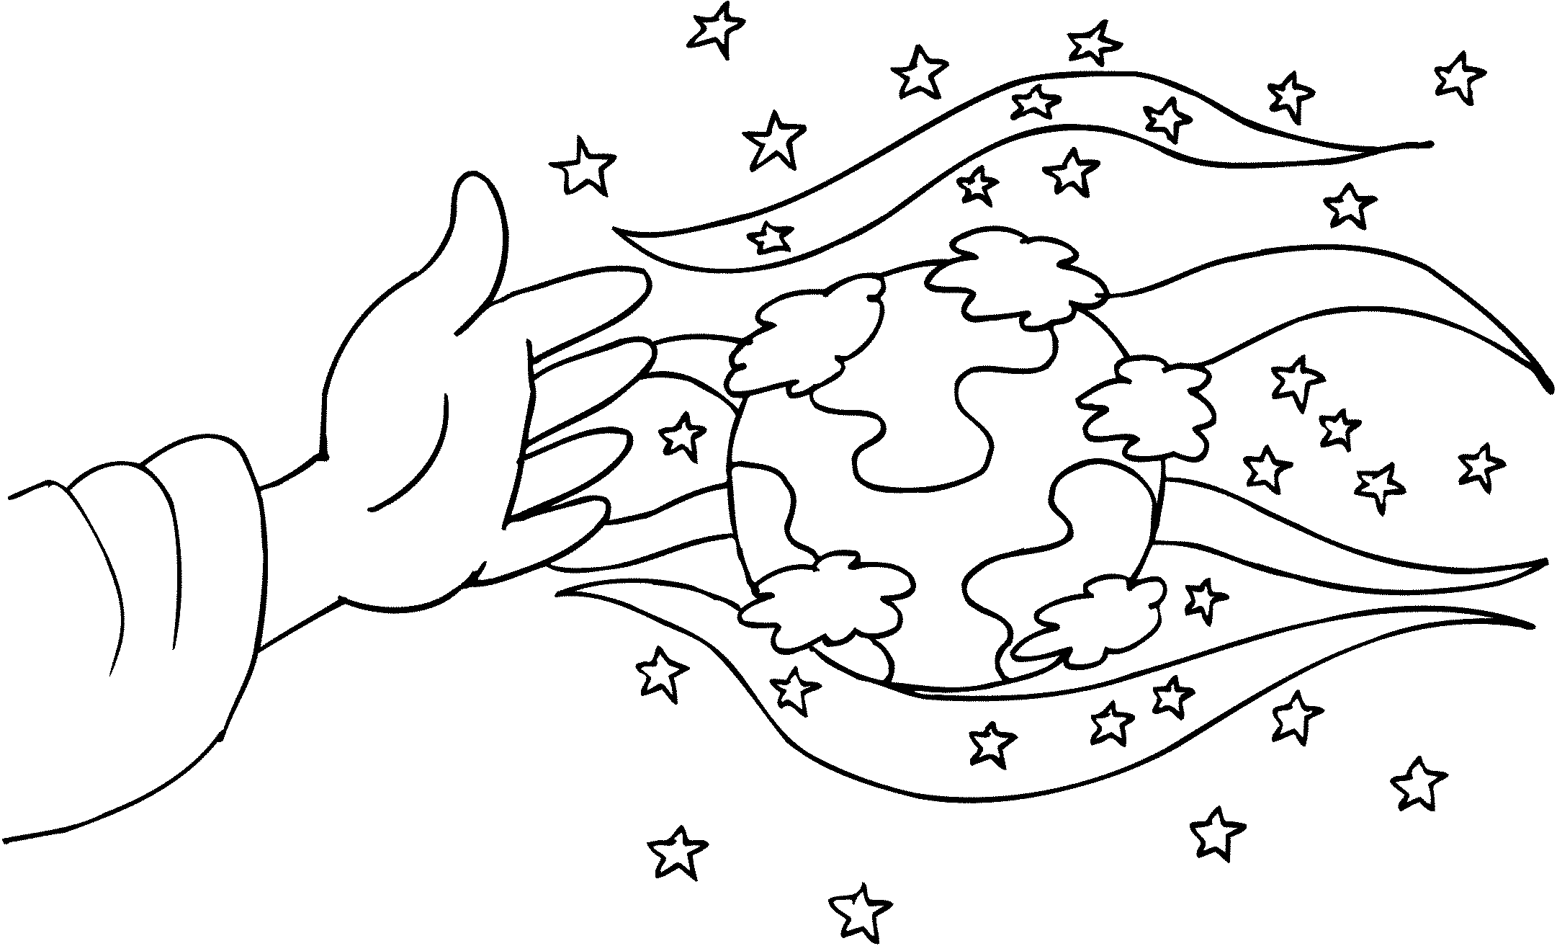

________________________________________________

PERFECT PLAN

BEGINNING
__________________________________________________
ADAM / EVE
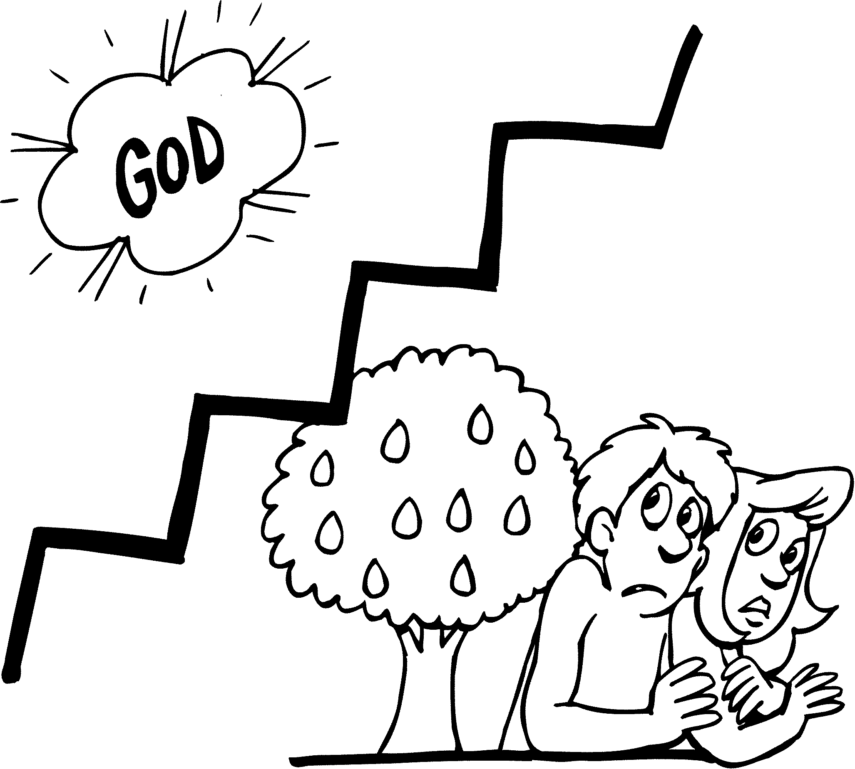

__________________________________________________
PROBLEM / PROMISE
BEGINNING
__________________________________________________
NOAH
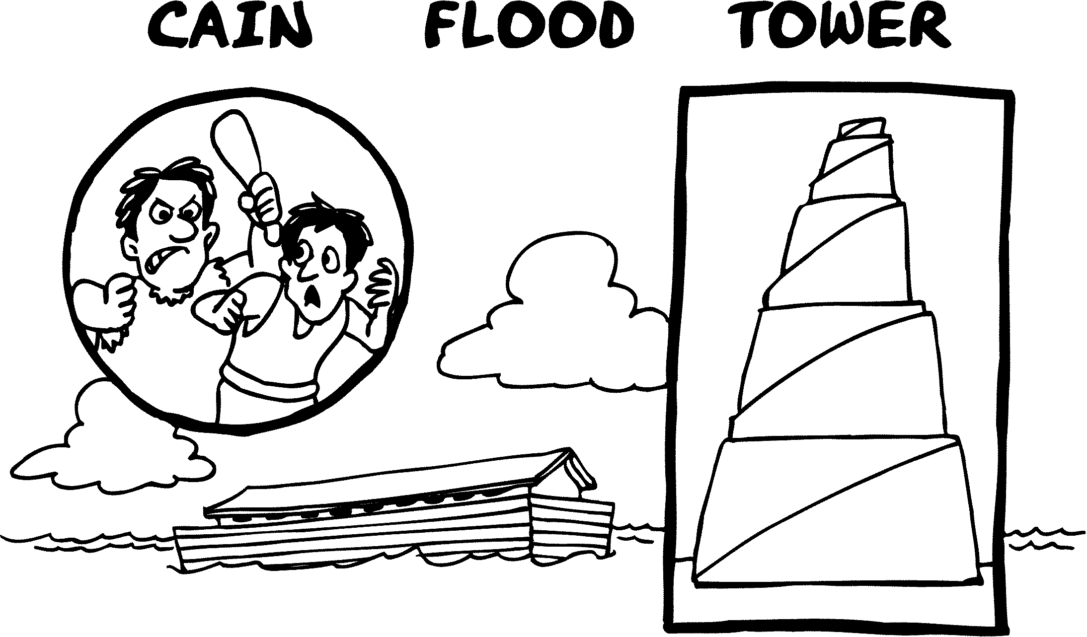

__________________________________________________
PRODUCTS OF SIN
FAMILY
__________________________________________________
ABRAHAM
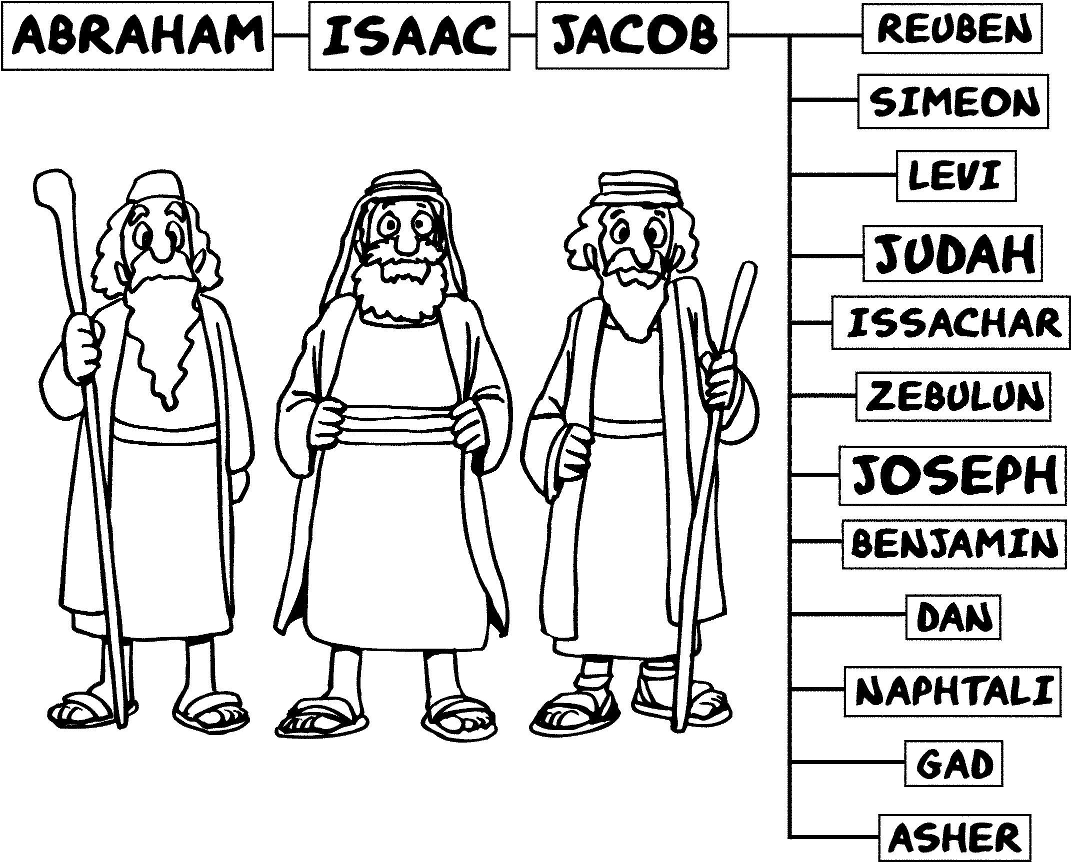

__________________________________________________
3 PROMISES GIVEN
EXODUS
__________________________________________________
JOSEPH / MOSES
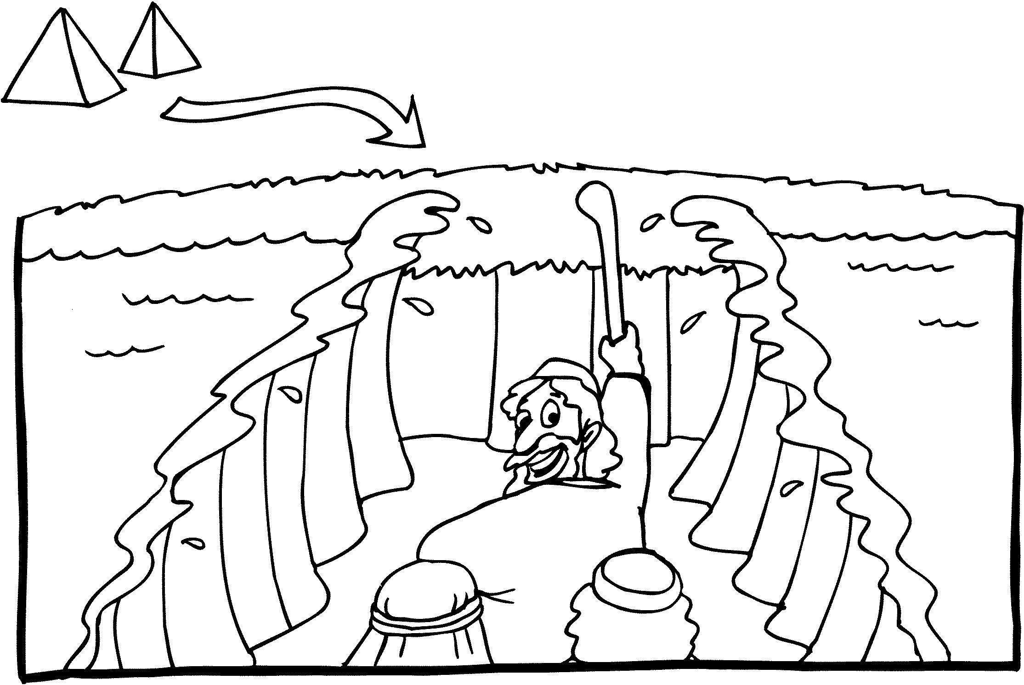

__________________________________________________
PHARAOH’S SLAVES

EXODUS
__________________________________________________
MOSES
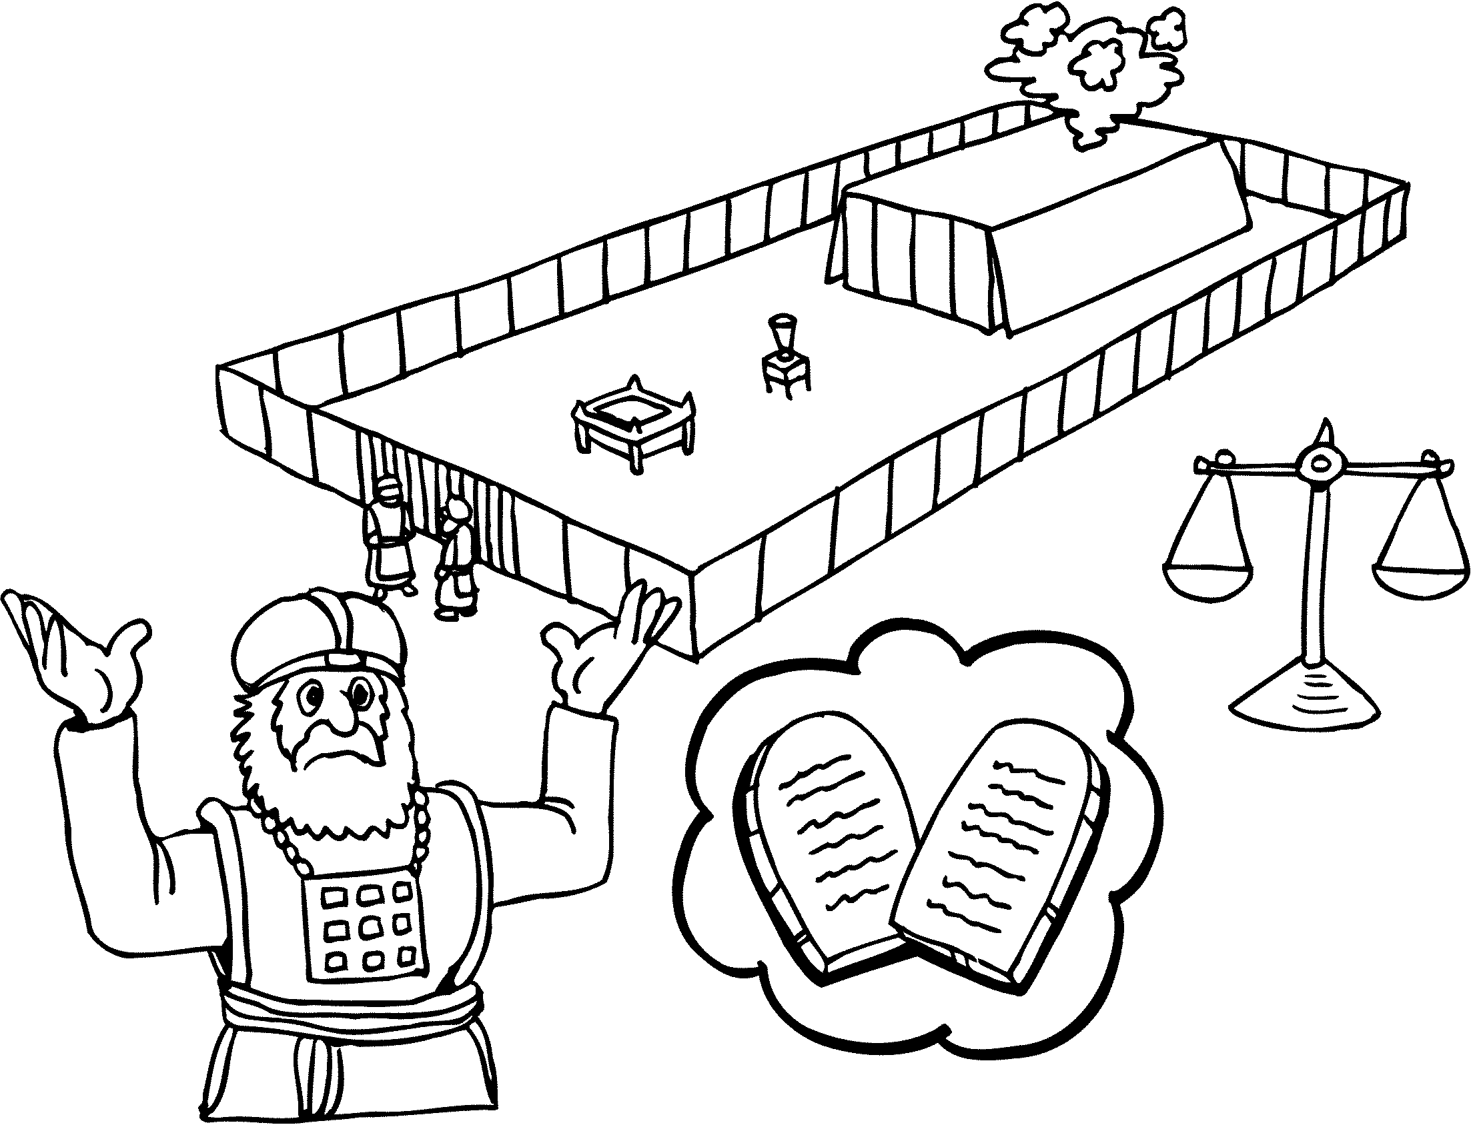

__________________________________________________
PROMISED NATION (1)
EXODUS
__________________________________________________MOSES / AARON
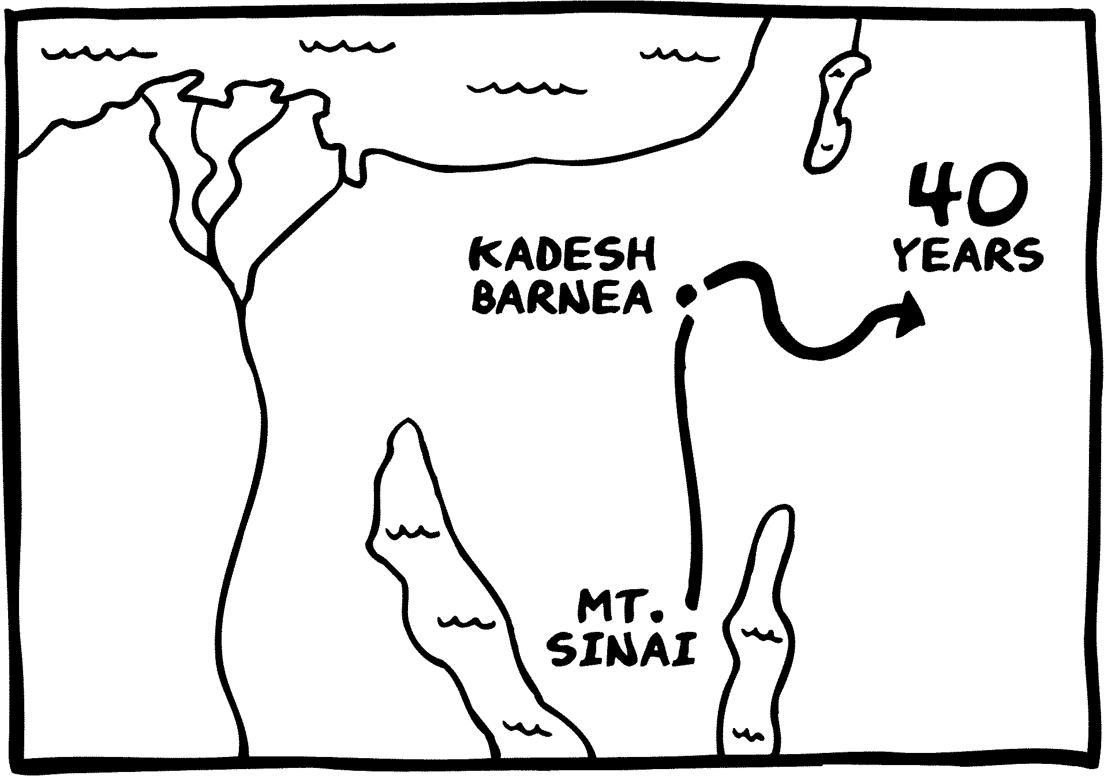

__________________________________________________
PERISH IN DESERT
CONQUEST
__________________________________________________
JOSHUA
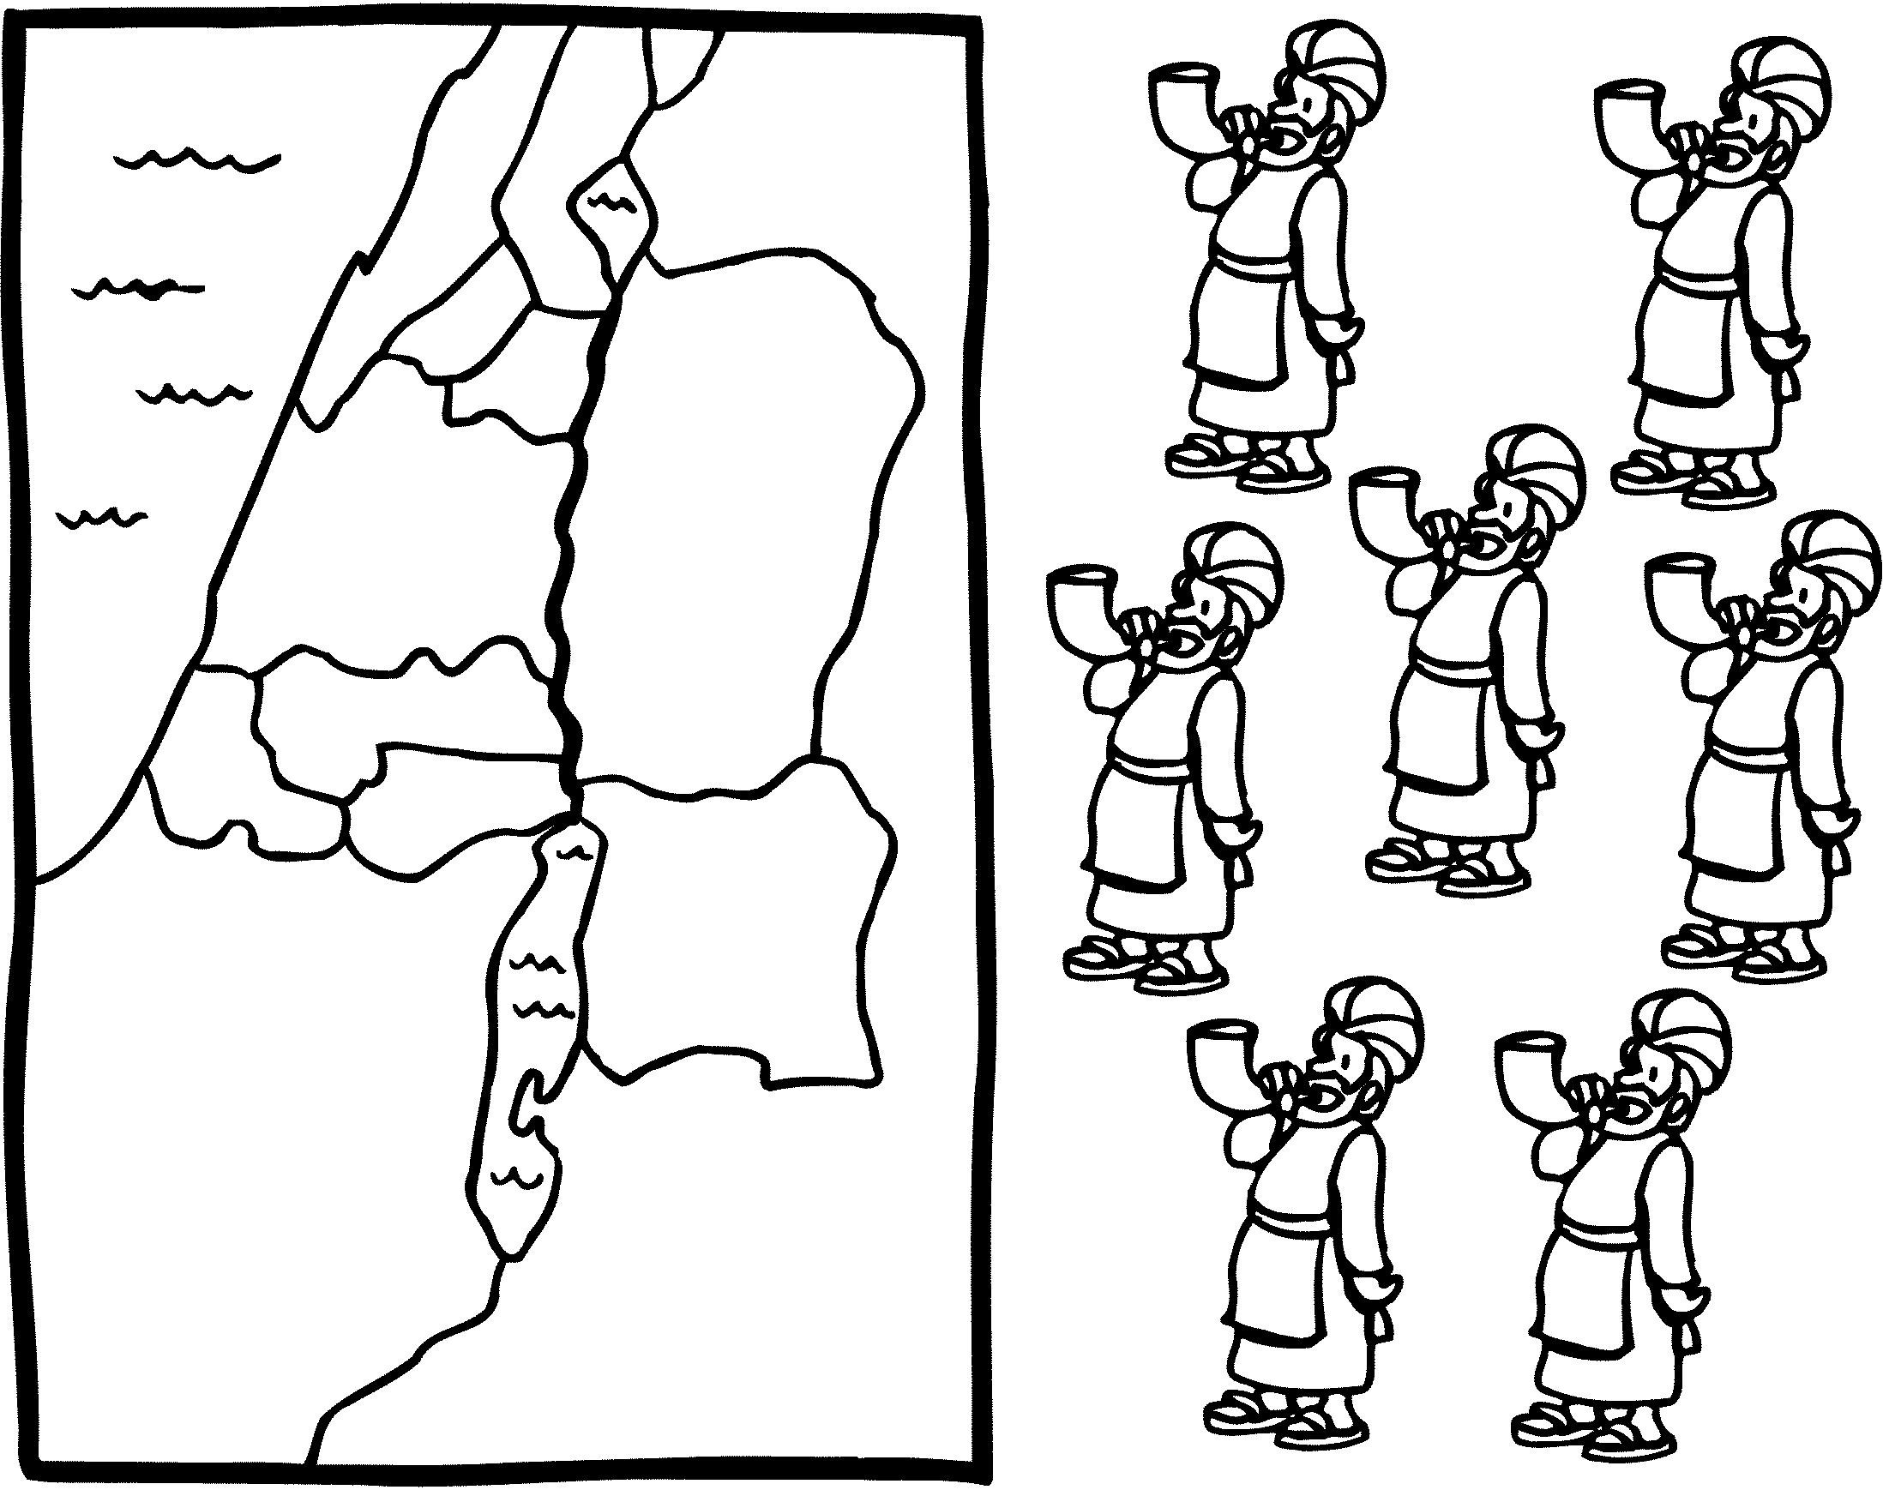

__________________________________________________
PROMISED LAND (2)
JUDGES
__________________________________________________
SAMUEL
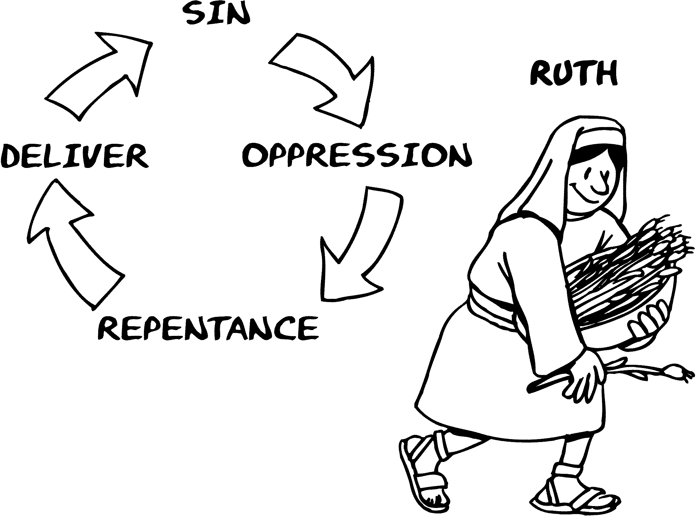

__________________________________________________
PATTERN - SIN
KINGDOM
__________________________________________________
DAVID
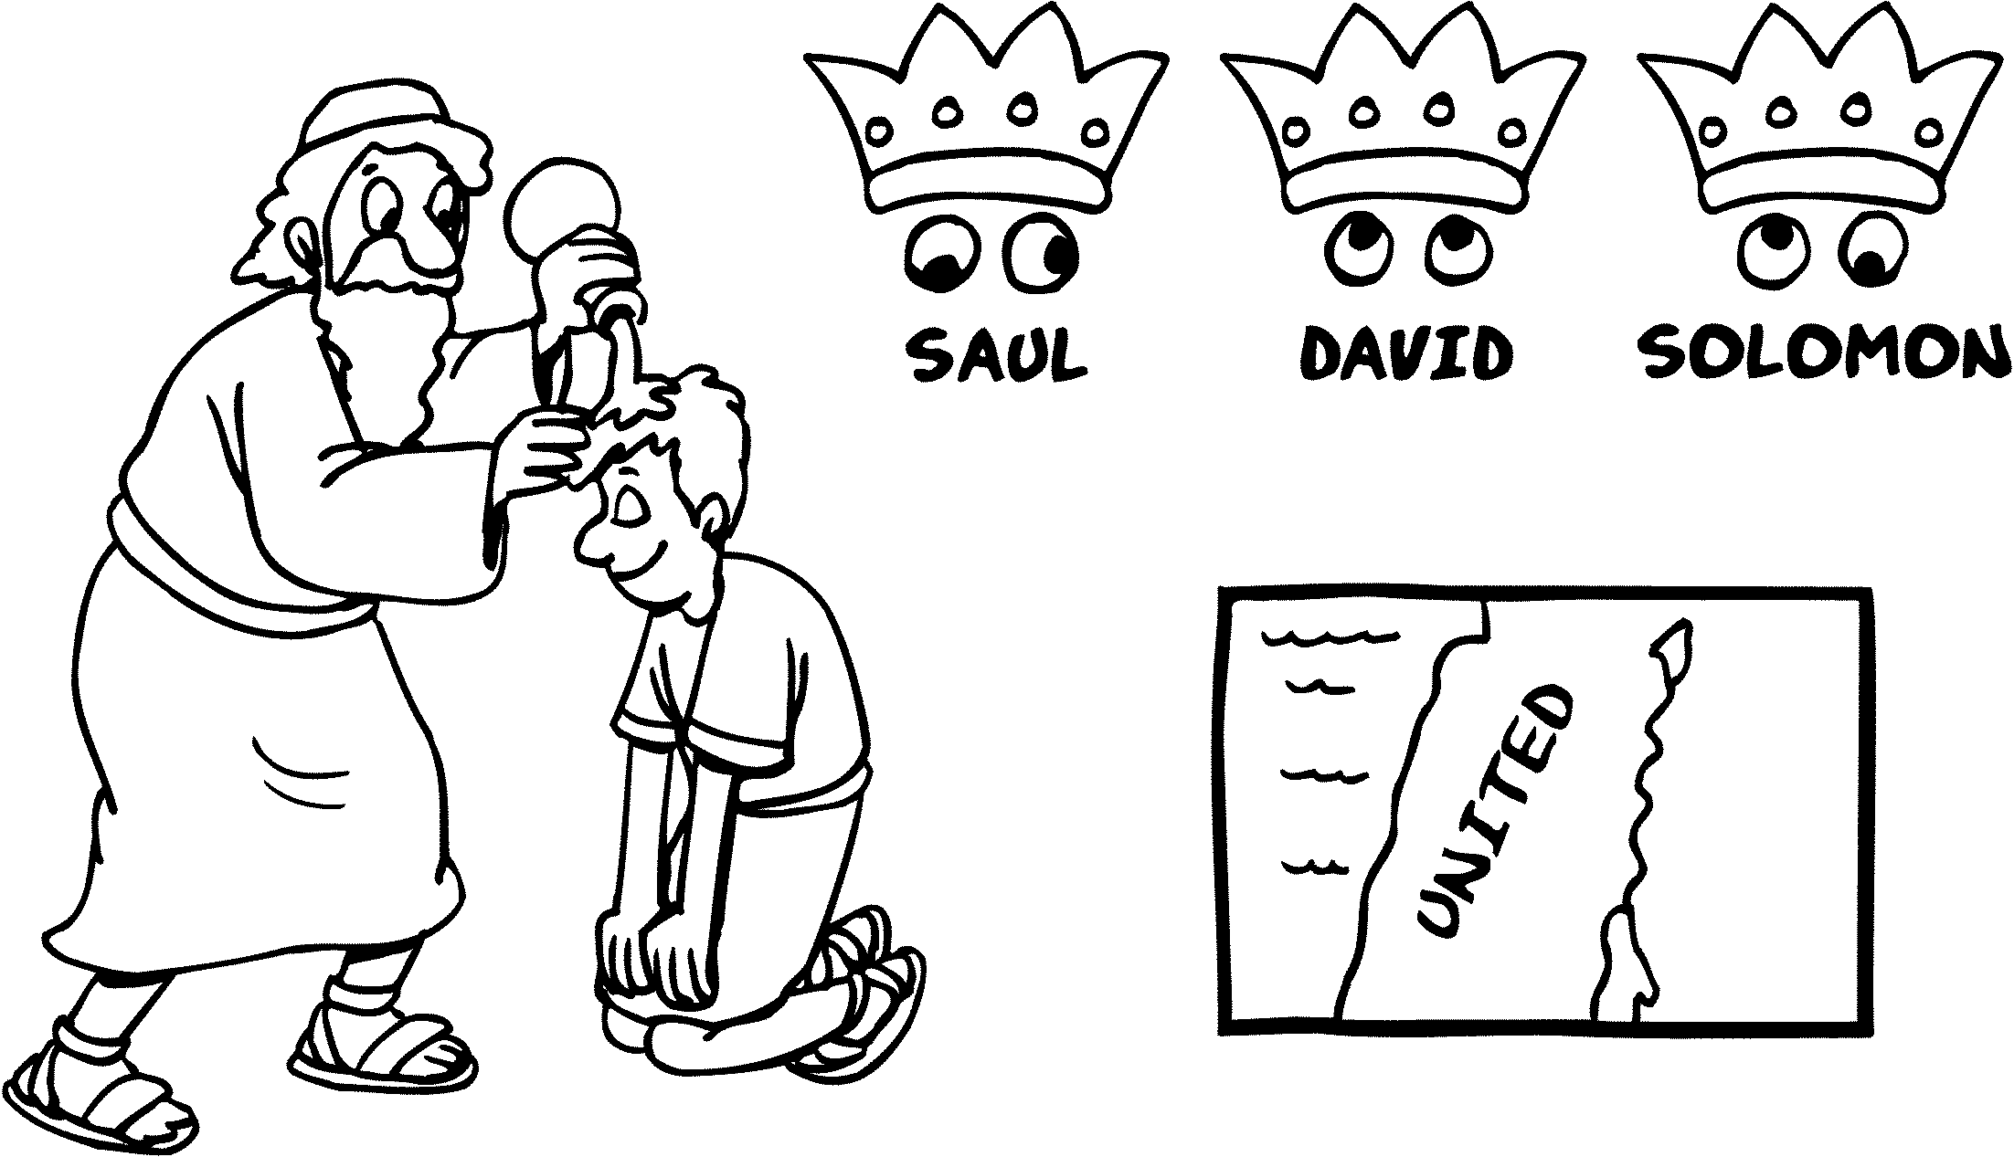

__________________________________________________
PALACES
KINGDOM
__________________________________________________
REHOBOAM
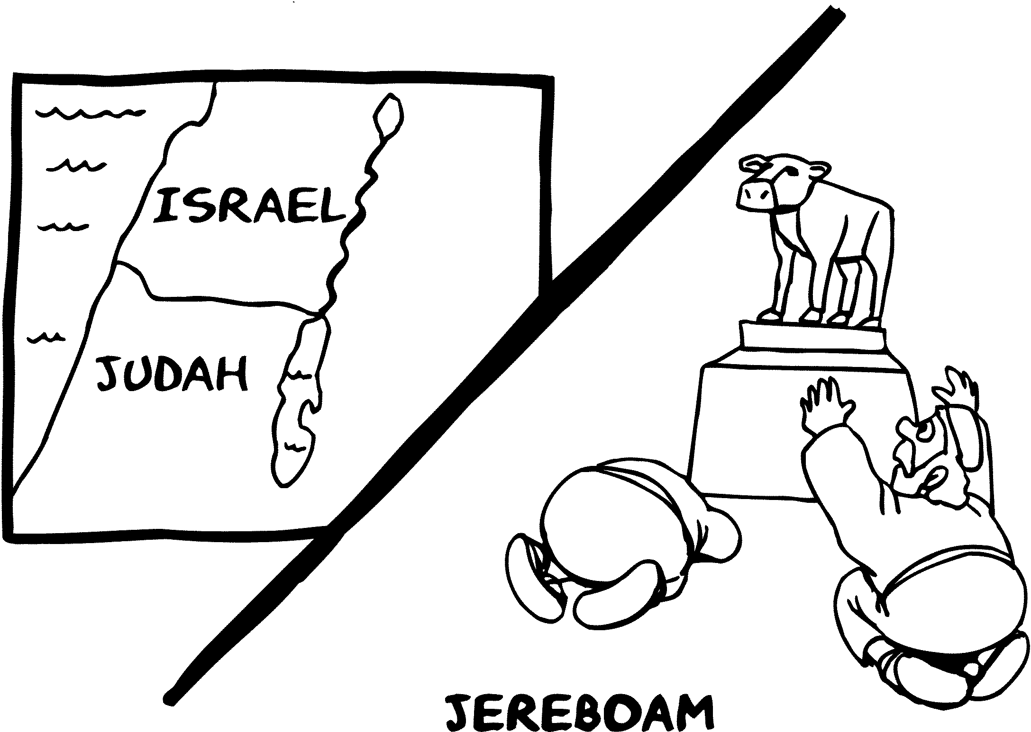

__________________________________________________
PAGAN IDOLS
KINGDOM
__________________________________________________
JOSIAH
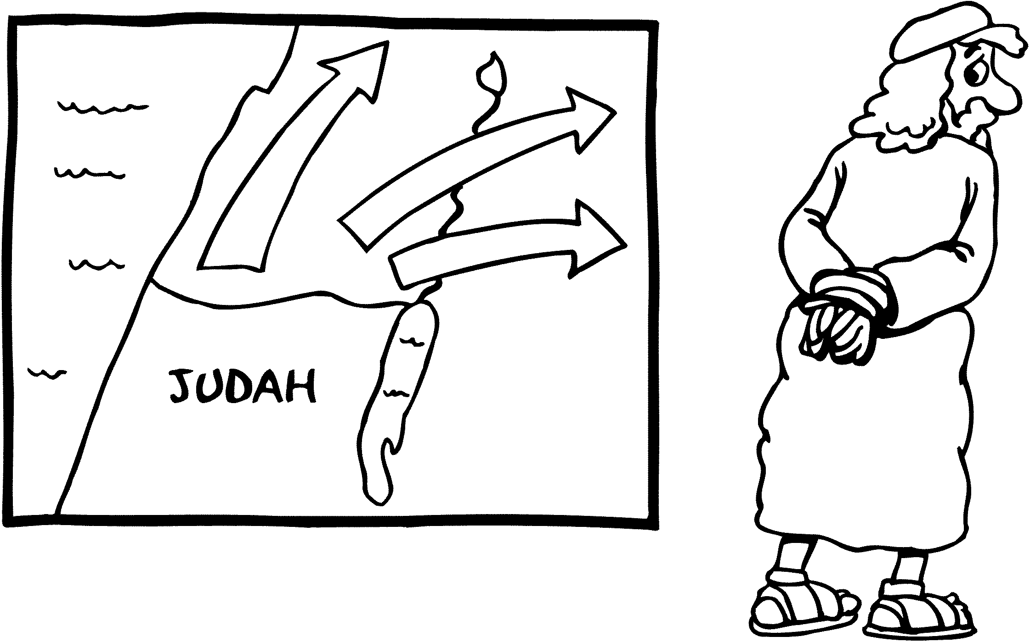

__________________________________________________
PUNISHMENT NEAR
KINGDOM
__________________________________________________
JOB / ISAIAH
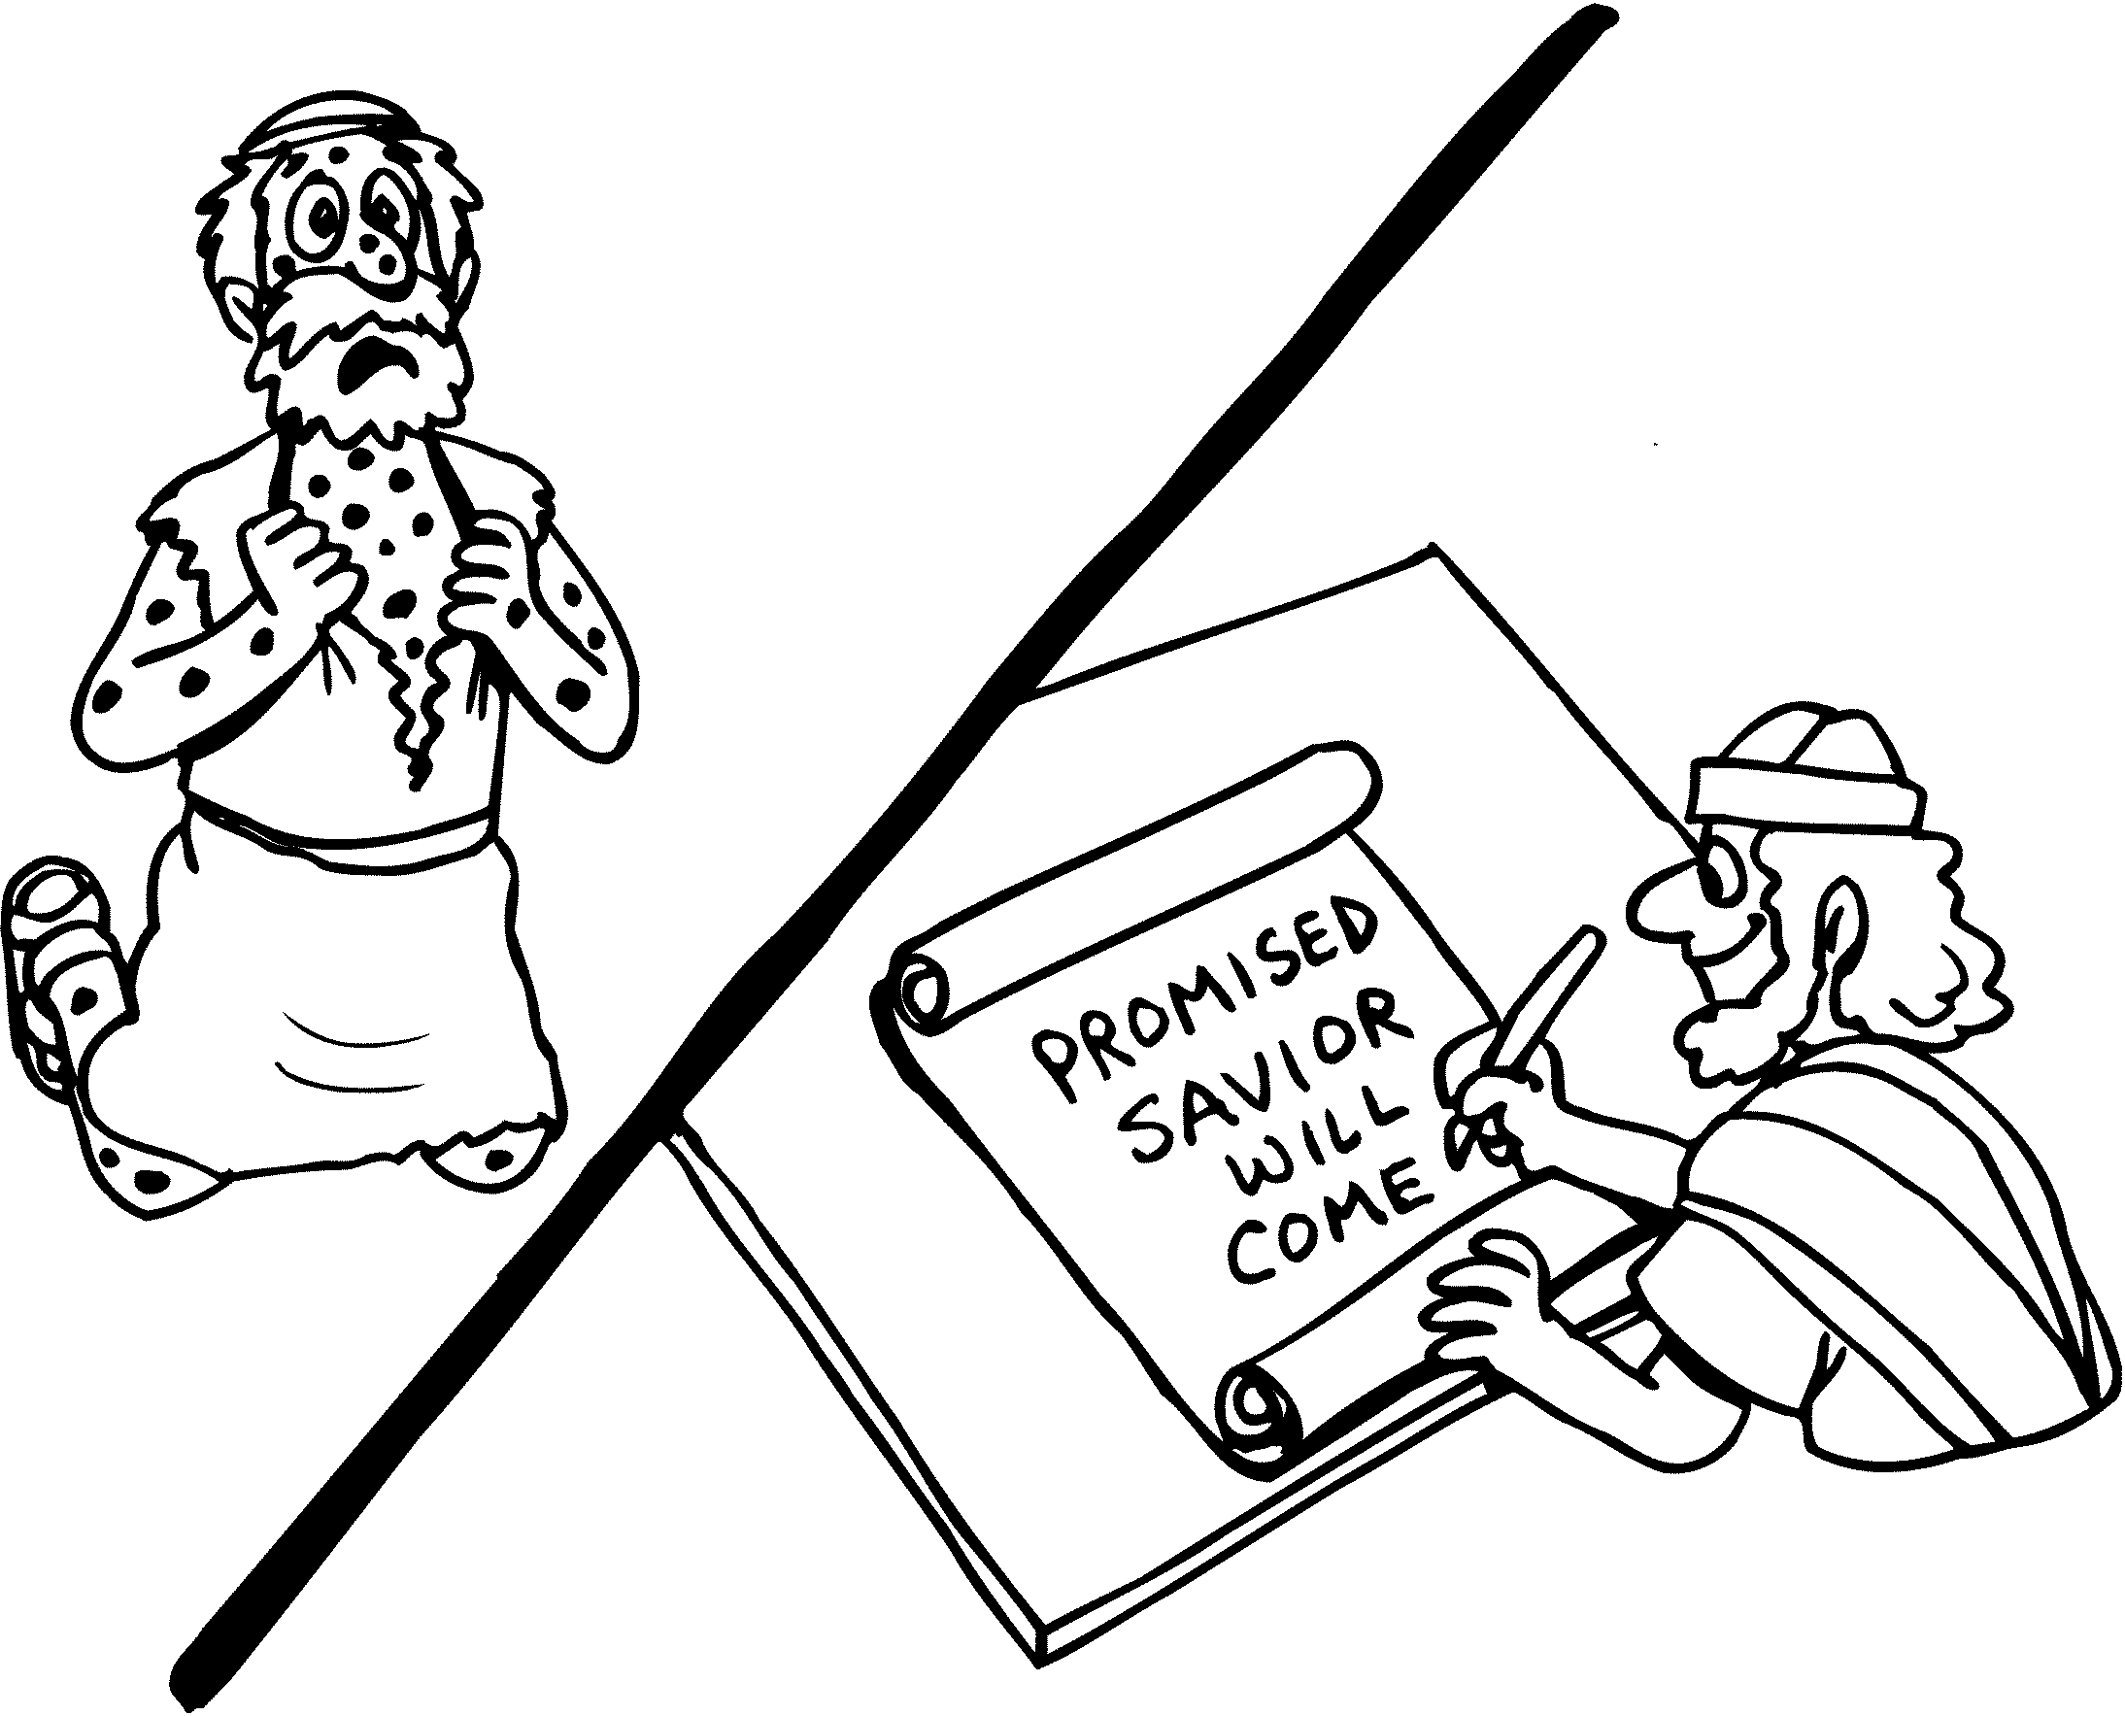

__________________________________________________
POETS / PROPHETS
EXILE
__________________________________________________
DANIEL
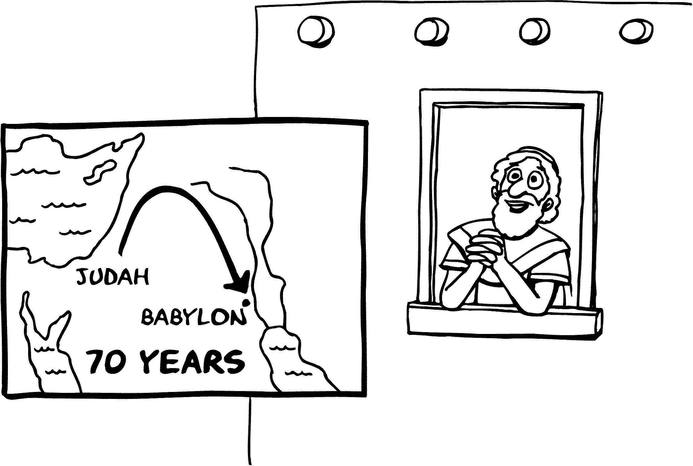

__________________________________________________
PRAYER WARRIOR
RETURN
__________________________________________________
EZRA
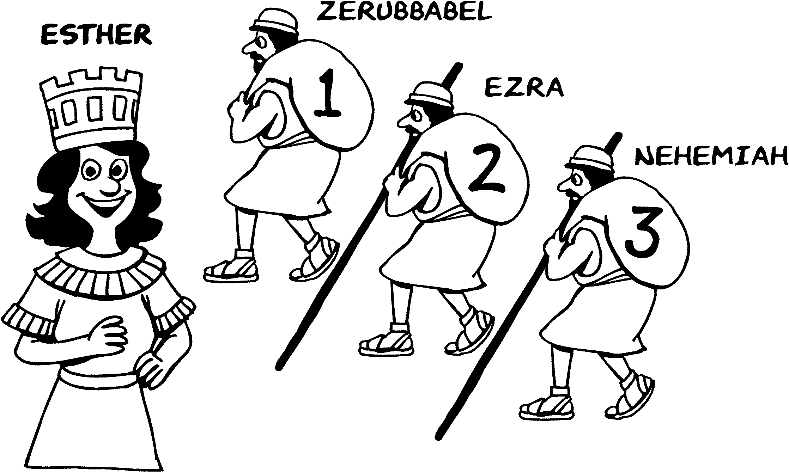

__________________________________________________

PRESERVATION

SILENCE
__________________________________________________
HEROD
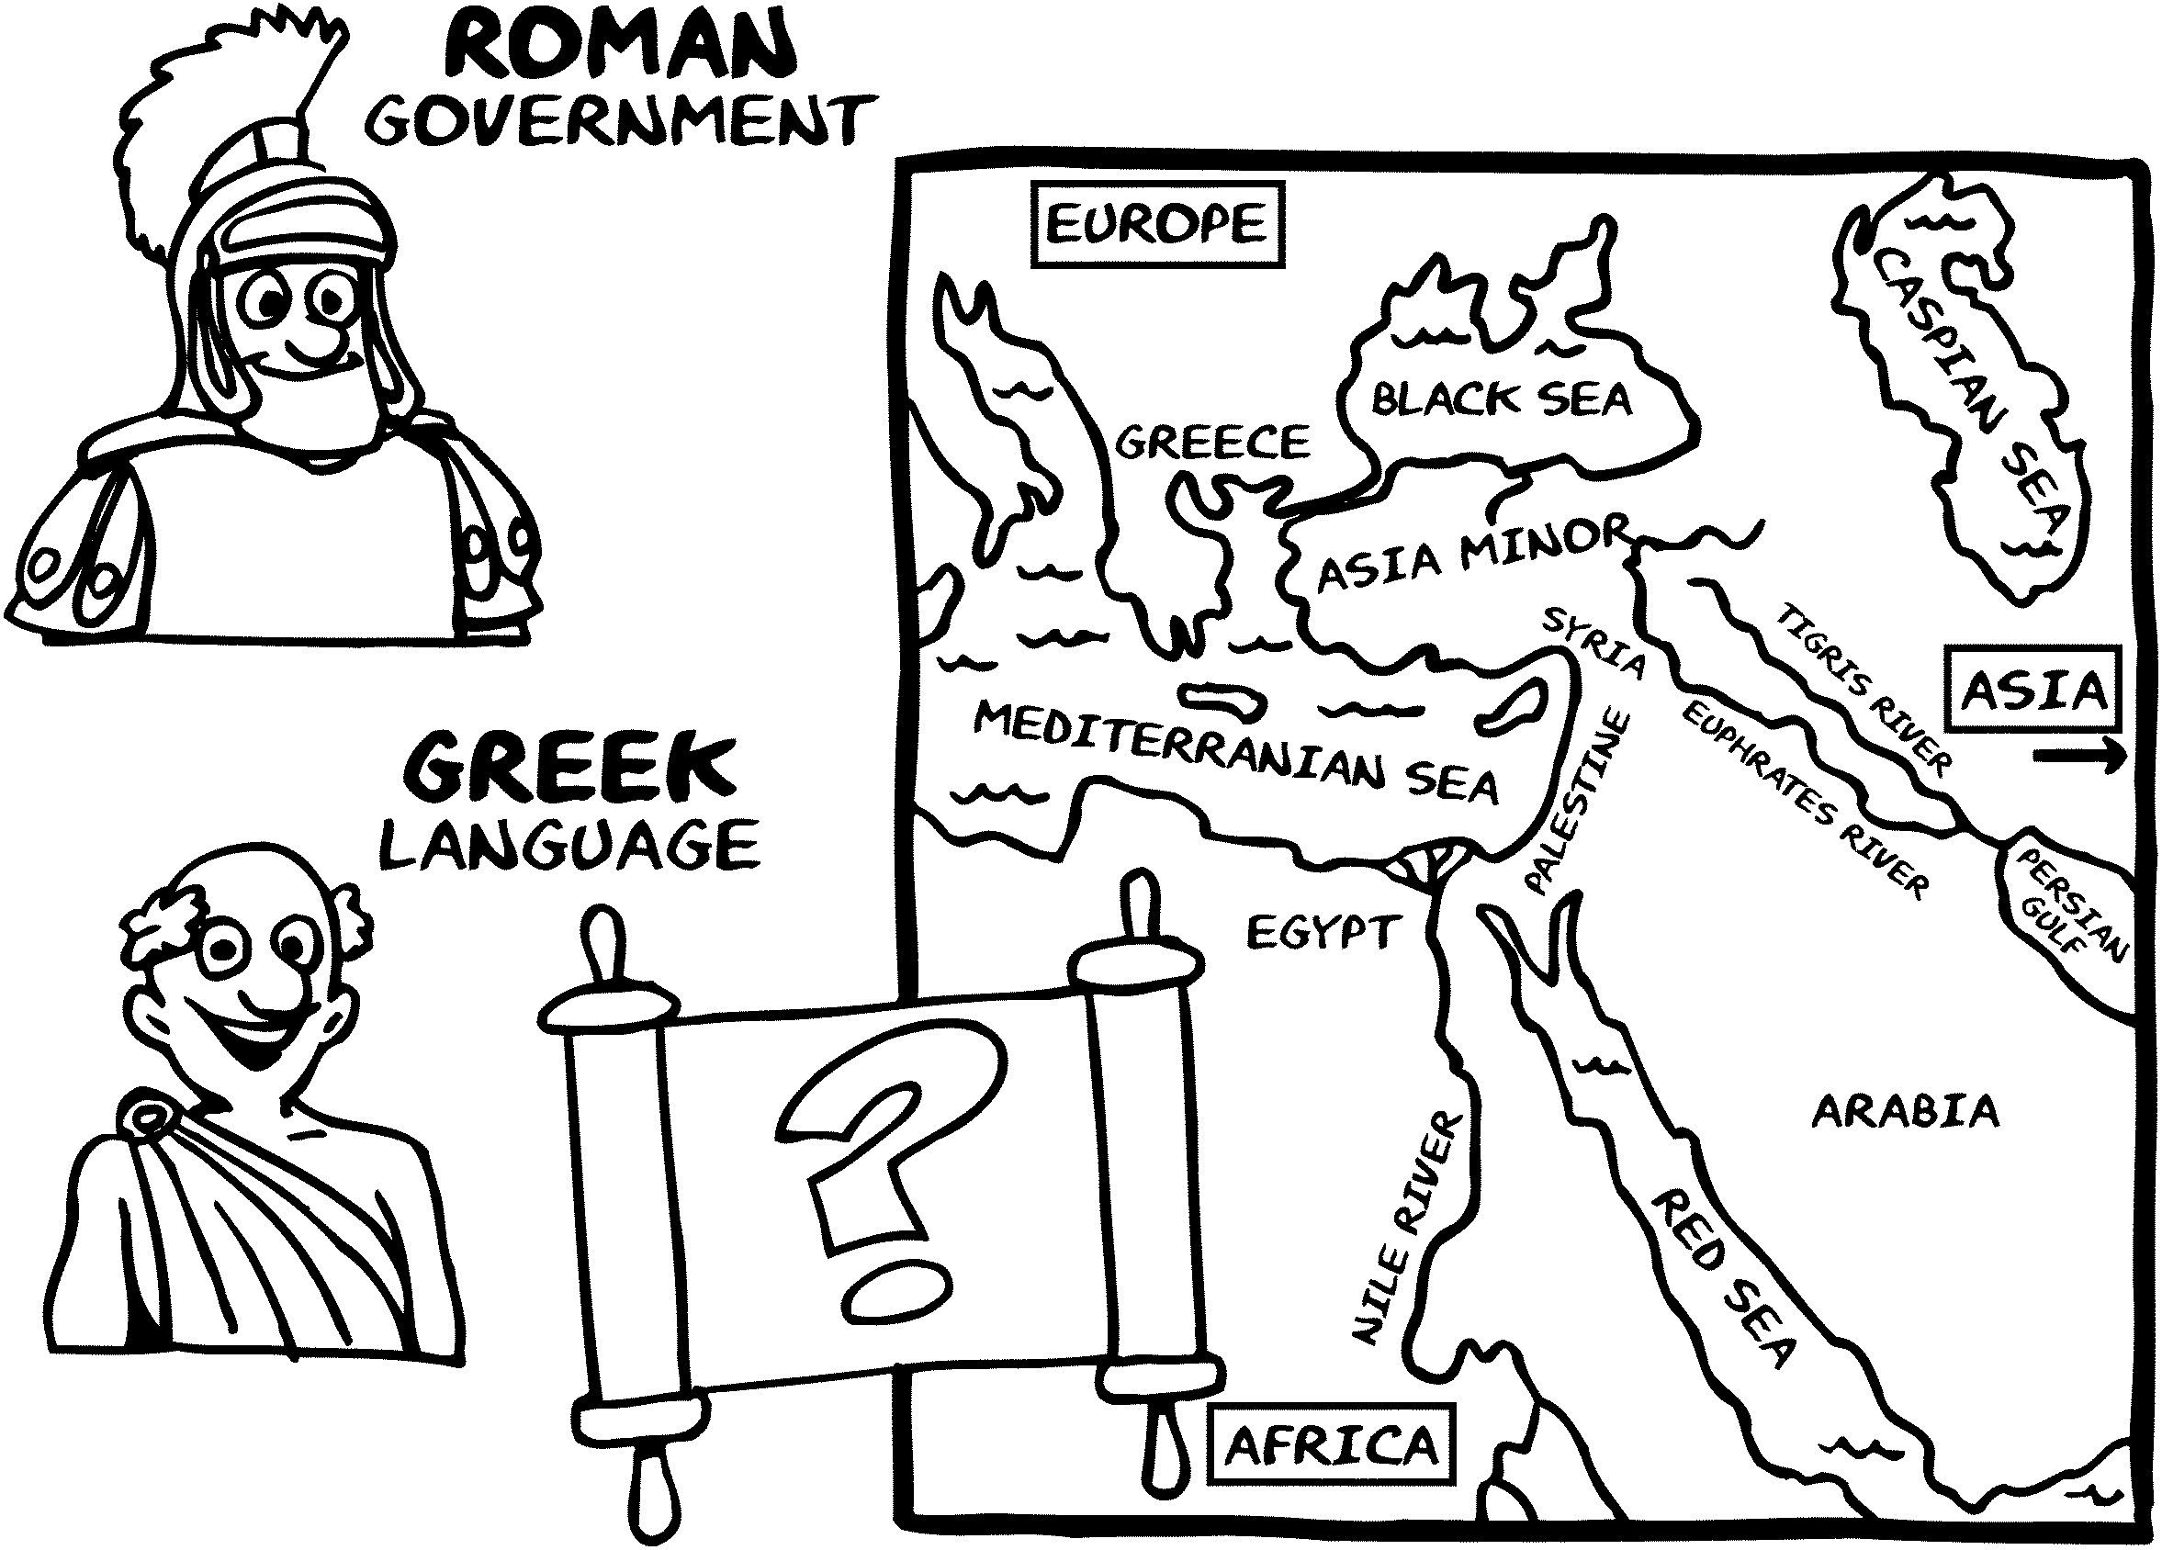

__________________________________________________
PREPARATION

GOSPEL
__________________________________________________
JESUS
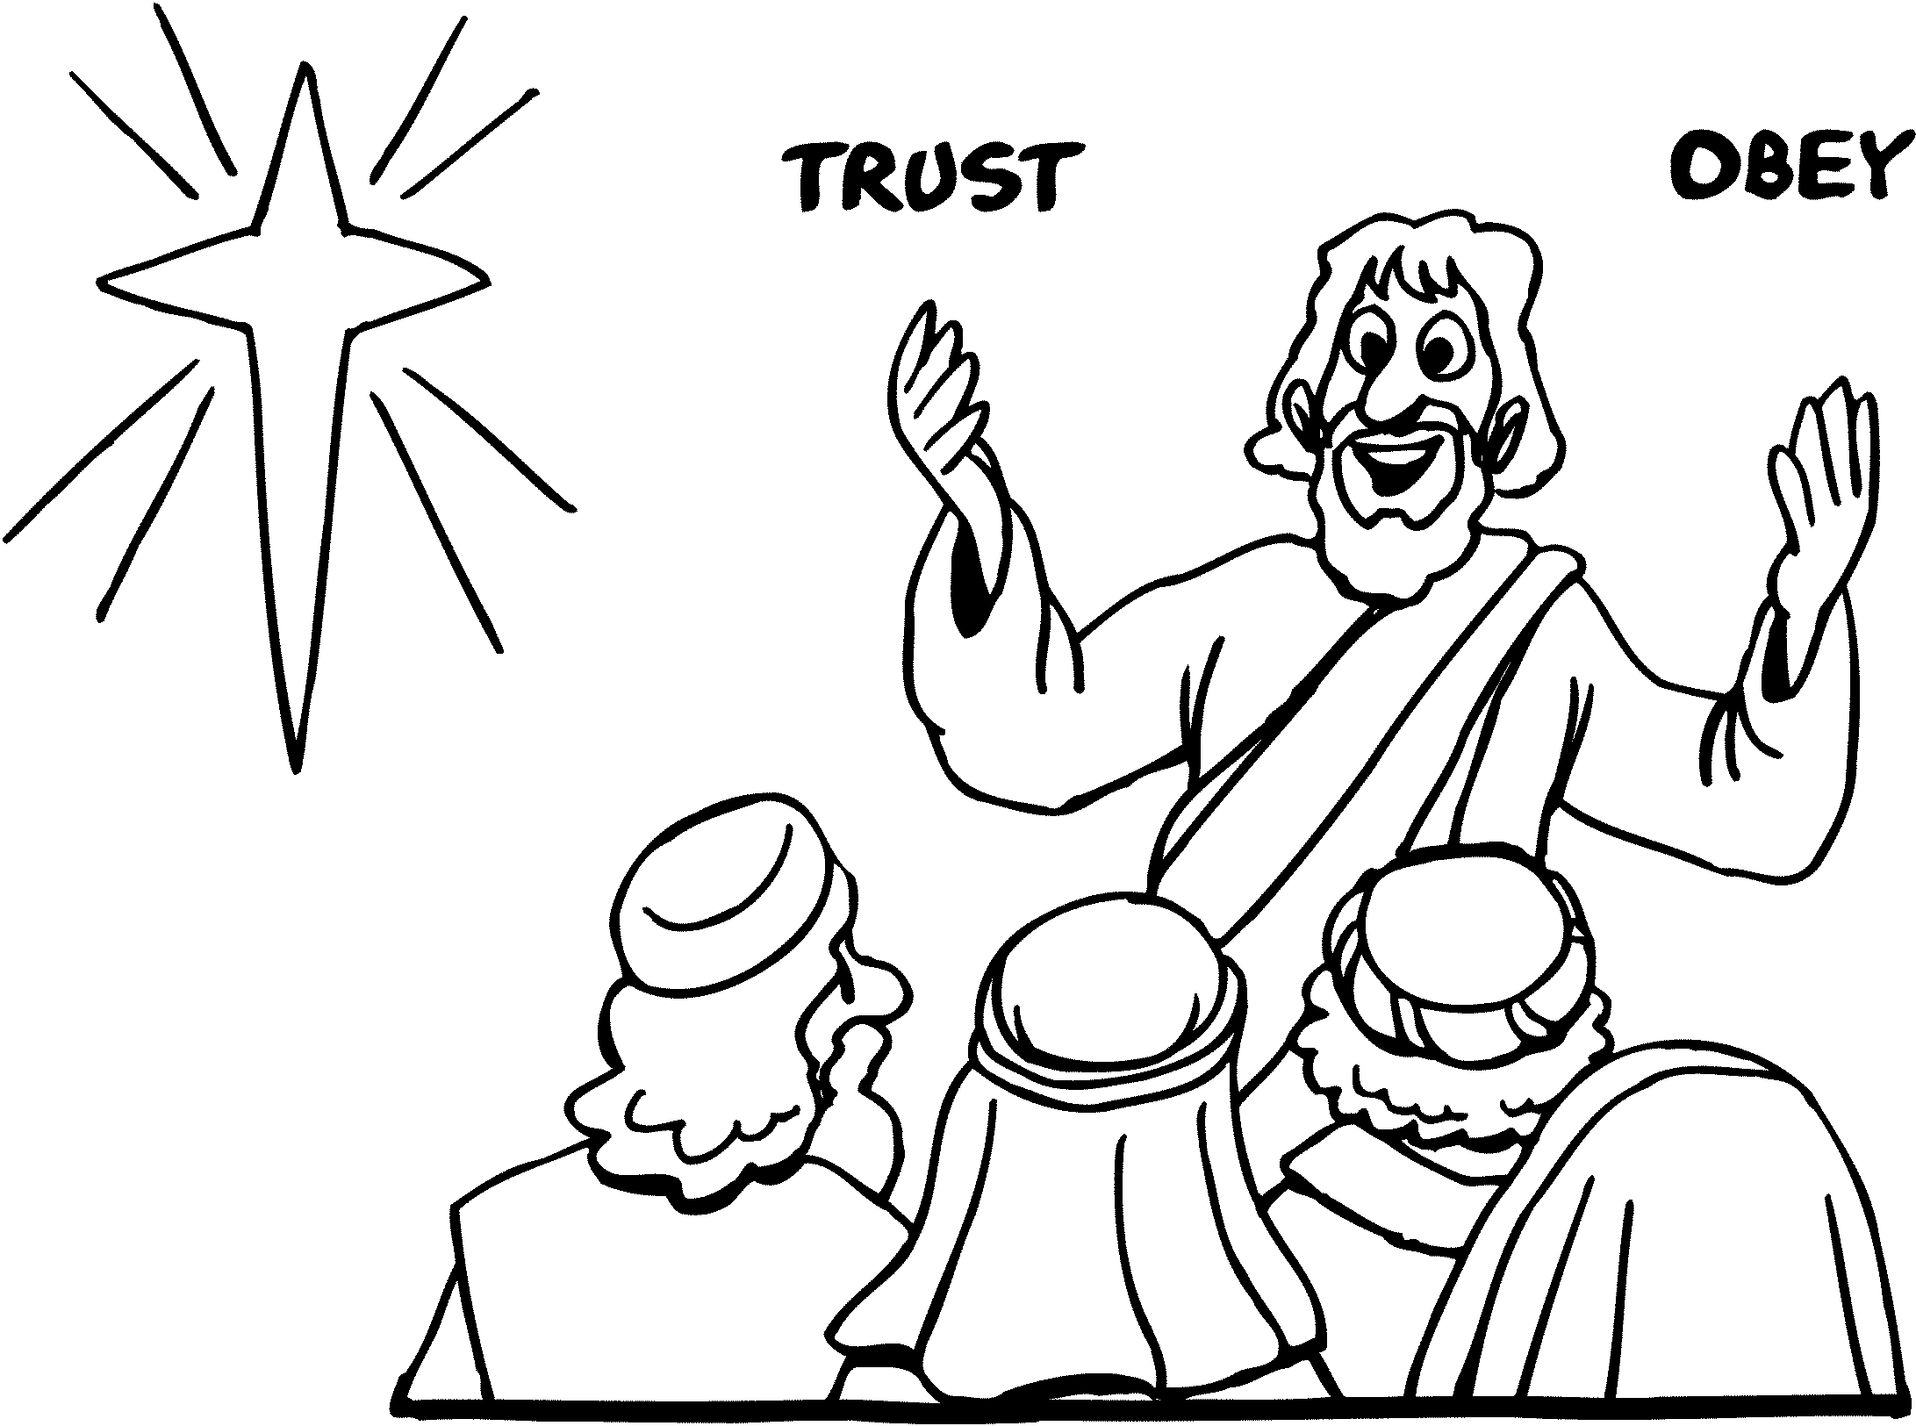

__________________________________________________
PROPHECIES - TRUE
GOSPEL
__________________________________________________
JESUS
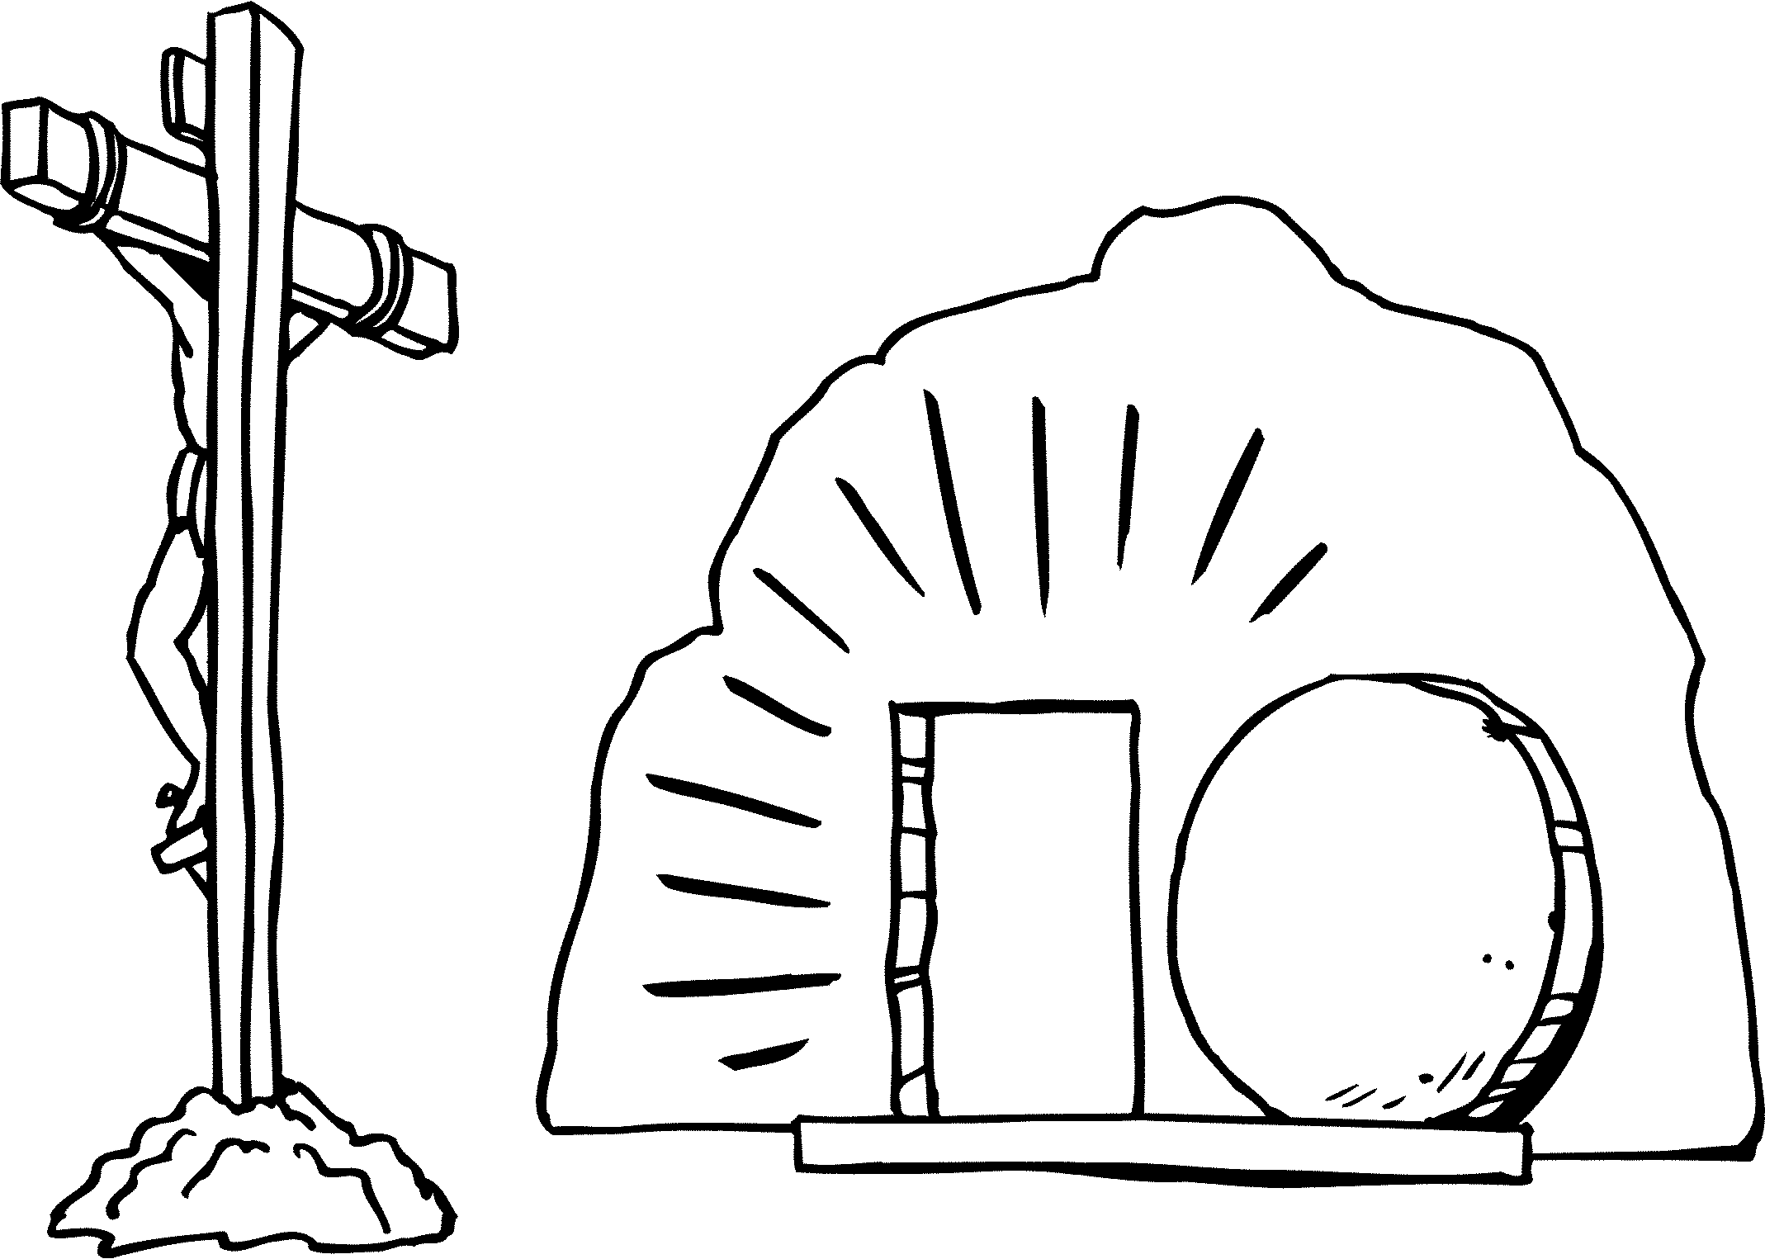

__________________________________________________
PROMISED SAVIOR (3)
CHURCH
__________________________________________________
PETER / PAUL
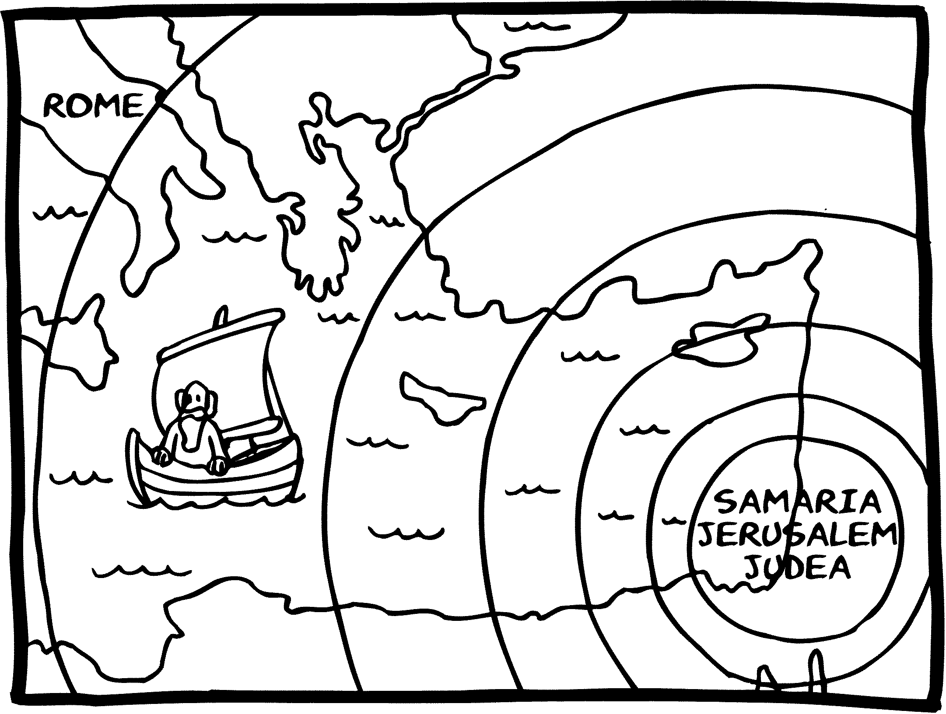

__________________________________________________
PROCLAMATION
MISSIONS
__________________________________________________
PAUL
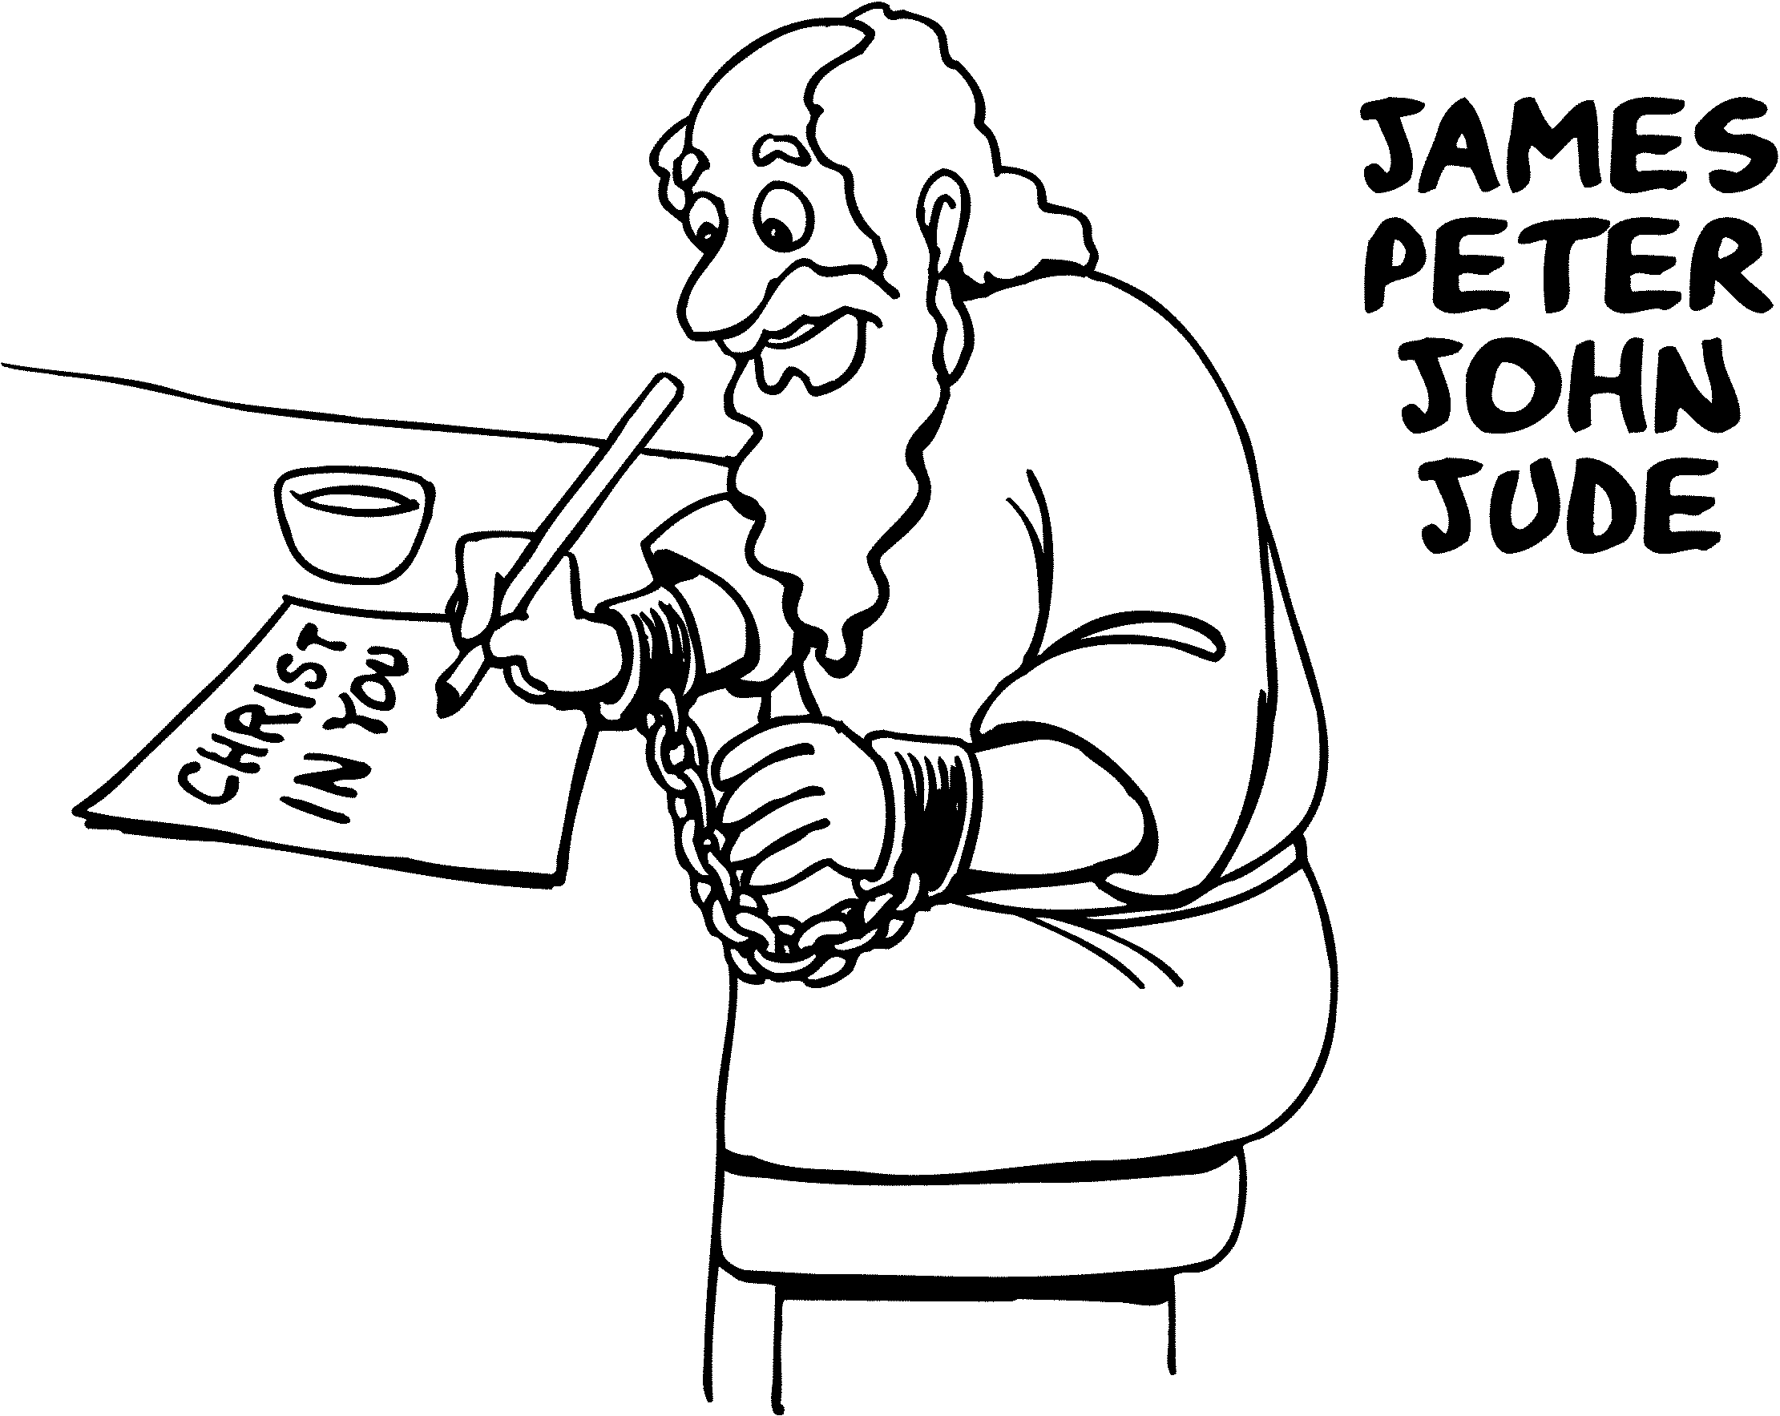

__________________________________________________
POSITION / PURPOSE

MARRIAGE
__________________________________________________
GOD YOU
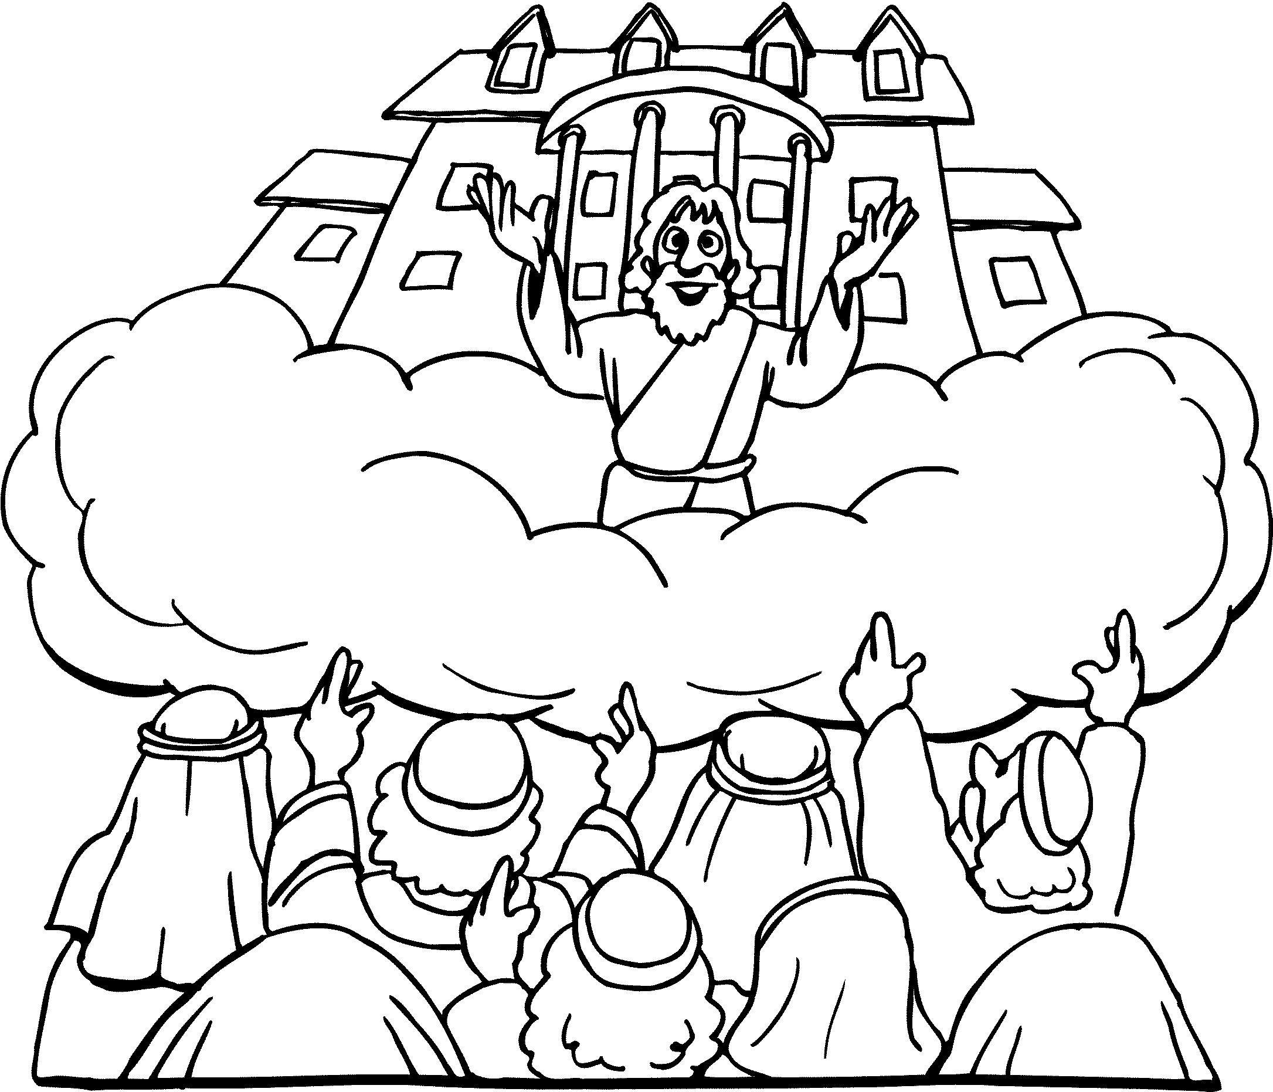

__

_______________________________________________
PARADISE

